**Implement a program for time series data cleaning, loading and handling time series data and pre- processing techniques**

AIM ***:* To implement a program for time series data cleaning , loading and handing time series data amd pre-processing techniques**

### Procedure:

### *1.Import and import all necessary library.*

### import os

### import numpy as np

### !pip install seaborn

### import matplotlib.pyplot as plt

### import seaborn as sns

### import warnings

*2.Reading and Displaying Data*

import pandas as pd

df = pd.read\_csv("AirPassengers.csv")

print(df.head())

df['Month'] = pd.to\_datetime(df['Month'], format='%Y-%m')

print(df.head())

df.index = df['Month']

del df['Month']

print(df.head())

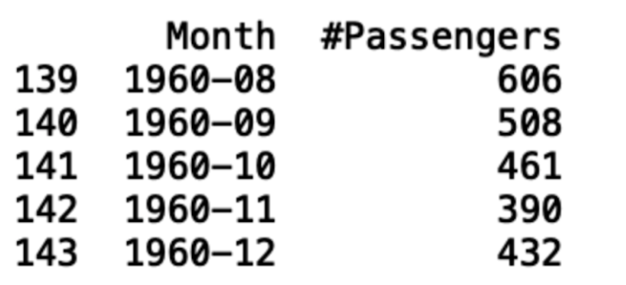

*3. generate a time series plot using [Seaborn and Matplotlib](https://builtin.com/data-science/data-visualization-tutorial" \t "_blank)*

import matplotlib.pyplot as plt

import seaborn as sns

sns.lineplot(df)

plt.ylabel(“Number of Passengers”)

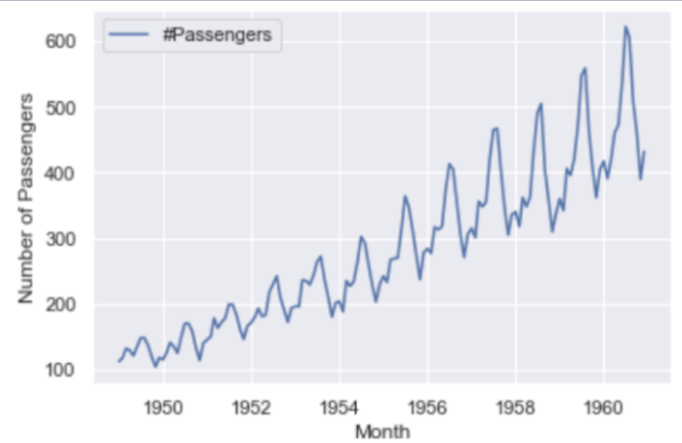

*4. Checking time series data for autocorrelation*

autocorrelation\_lag1 = df['#Passengers'].autocorr(lag=1)

print("One Month Lag: ", autocorrelation\_lag1)

autocorrelation\_lag3 = df['#Passengers'].autocorr(lag=3)

print("Three Month Lag: ", autocorrelation\_lag3)

autocorrelation\_lag6 = df['#Passengers'].autocorr(lag=6)

print("Six Month Lag: ", autocorrelation\_lag6)



*5.  visualize the trends in time series data.*

from statsmodels.tsa.seasonal import seasonal\_decompose

del train['Date']

decompose = seasonal\_decompose(df['#Passengers'],model='additive', period=7)

decompose.plot()

plt.show()

*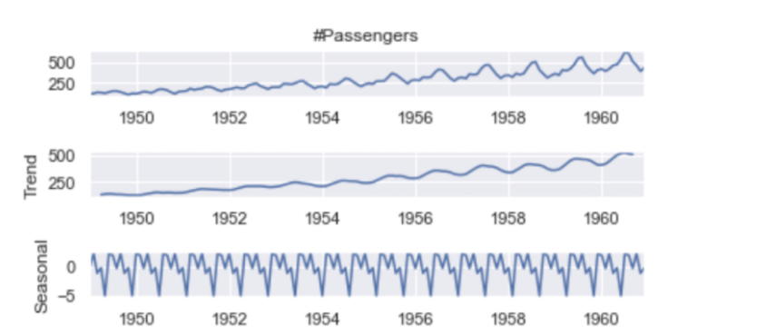*

### Result:

### Thus the program for time series data cleaning , loading and handling has been done succesfully